PROJECT

PERsonal Expense tracker

## 

## Course: Introduction to Program SOLVING

## Student Name: Jahnavi Gaur

## Instructor: Dr. Sasmita Padhy

### 1️⃣ Problem Statement

Most students and individuals spend money daily on food, transport, recharge, shopping, etc., but they often forget where their money goes. They struggle to track daily spending and face difficulty managing their monthly budget.

To solve this problem, the Personal Expense Tracker provides a very small and simple system where the user can record all expenses and manage them easily through basic operations.

### Introduction

Managing daily expenses seems simple, but most of us forget where our money actually goes. Whether it’s snacks, travel, online purchases, or small personal items, everything adds up. The idea behind this project was to create a very simple personal expense tracker that anyone can use to record their spending during the day.

The project is written completely in Python and focuses more on understanding concepts rather than building a complex application. It uses a basic console menu and stores data only while the program is running. I designed it in a modular way so that each part of the project is in a separate file, which also helped me understand how real projects are structured.

### 2️⃣ Objectives

The main objectives of the Personal Expense Tracker are:

1. To help users record and organize their daily expenses.
2. To allow users to Add, View, Update, and Delete expenses.
3. To manage all data temporarily in Python using simple lists.
4. To build a modular Python program with multiple files (minimum 5 modules).
5. To improve understanding of CRUD operations and object-oriented programming.
6. To create a functional console-based expense management tool.

### 3️⃣ Functional Requirements

✔ Add Expense

The user can enter amount, category, date, and a small note.

✔ View Expenses

Shows all expenses recorded in the session.

✔ Update Expense

Allows editing of selected expense details.

✔ Delete Expense

Removes a selected expense from the list.

✔ Exit

Terminates the program (data is erased as no database is used).

### 4️⃣ Non-Functional Requirements

✔ Usability

The interface must be simple so anyone can use it without training.

✔ Performance

All operations must be quick since the data is stored in RAM.

✔ Portability

The system must run on any computer with Python installed.

✔ No Permanent Storage

Data should not be saved permanently; program resets when stopped.

✔ Maintainability

The system must be modular with separate Python files.

### 5️⃣ System Architecture Diagram

## 

### 6️⃣ Process Flow / Workflow Diagram

## 

### 7️⃣ UML Diagrams

✔ Use Case Diagram

Actor: User  
System: Personal Expense Tracker

Use cases:

* Add Expense
* View Expenses
* Update Expense
* Delete Expense
* Exit

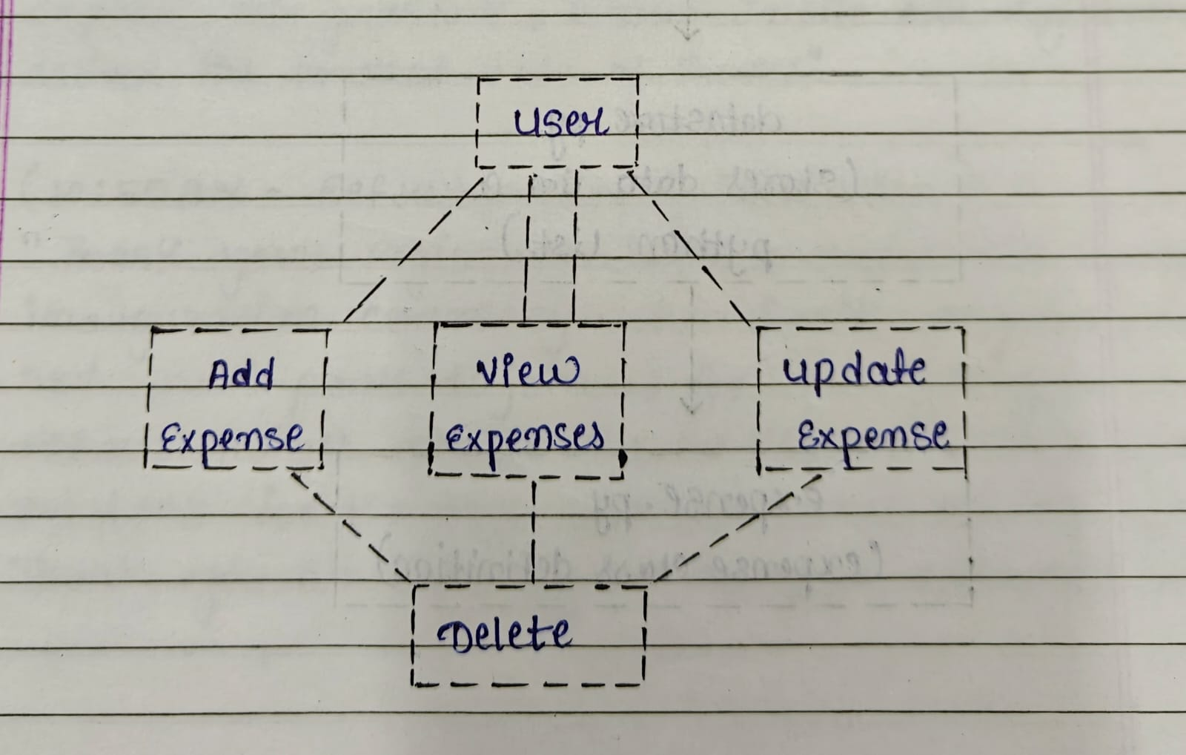

✔ Class Diagram

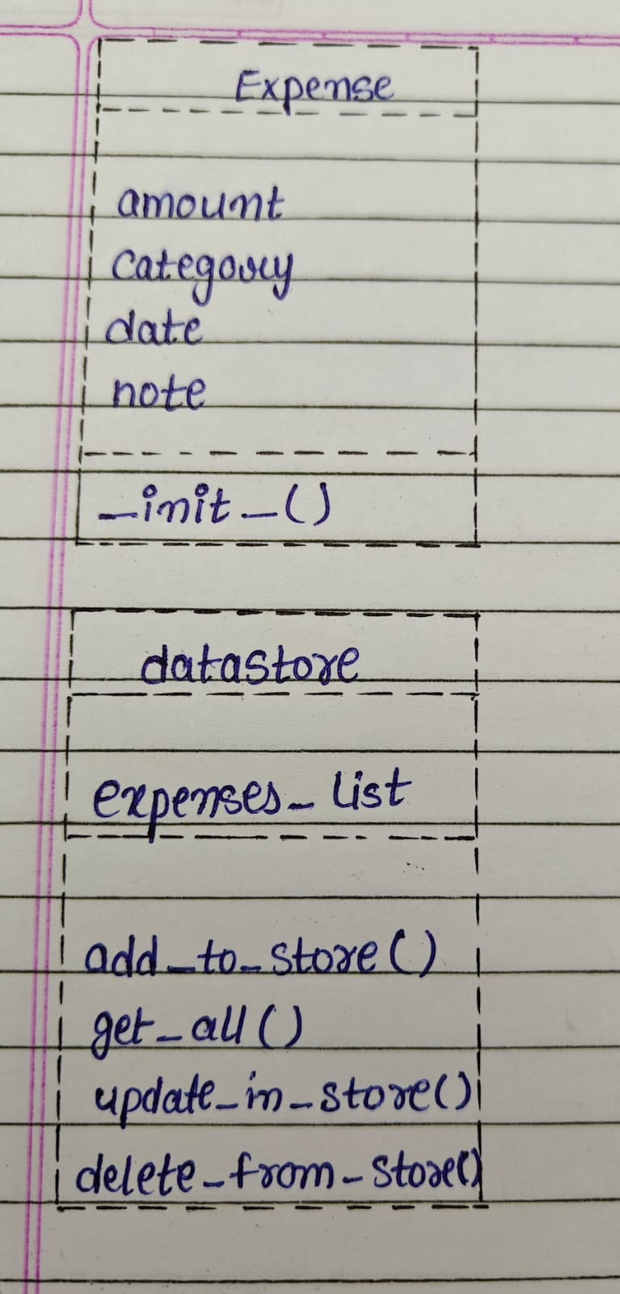

✔ Sequence Diagram (Add Expense)

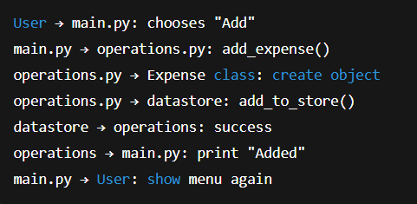

### 8️⃣ Storage Design (No Database Used)

Since this project does NOT use any database or text file, we use in-memory storage.

Data Structure:

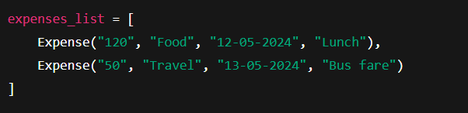

Why In-Memory List?

* Very simple for beginners
* Fast
* No installation required
* Suitable for school-level Python projects
* Data automatically clears when program stops

### 9. Design Decisions & Rationale

While making this project, I had to make a few choices so the system would stay simple and easy to understand:

1. Using a list instead of a database  
   Since this is a small, learning-level project, storing data in a Python list was enough. It removed the need to manage files or install databases.
2. Creating multiple Python modules  
   To keep the code clean, I divided it into separate files like main.py, operations.py, and so on. This made the project look organised and also helped me understand modular programming.
3. Making an Expense class  
   Instead of mixing data everywhere, I created one class called Expense that holds all details of a single expense. This makes the project more readable.
4. Using a simple text menu  
   A graphical interface wasn’t needed. A menu that appears in the terminal is more than enough for the purpose of this project.
5. No permanent storage  
   The aim was to learn CRUD operations, not to build a full tracking system. So I kept the data only for one session, which also makes the program lighter.

### 10. Implementation Details

I used Python 3 to build the entire program. The project is divided into 5 modules:

* main.py – shows the menu and controls the flow
* display.py – prints the menu
* expense.py – defines the Expense class
* datastore.py – stores all expenses in a list
* operations.py – contains functions to add, update, delete, and view expenses

The program starts from main.py, where the user selects an option. Based on the option, the appropriate function from operations.py runs, and the stored data is maintained in the list defined in datastore.py.

Everything happens in the terminal, which keeps it very simple.

### 11. Screenshots / Results

-> When the program starts

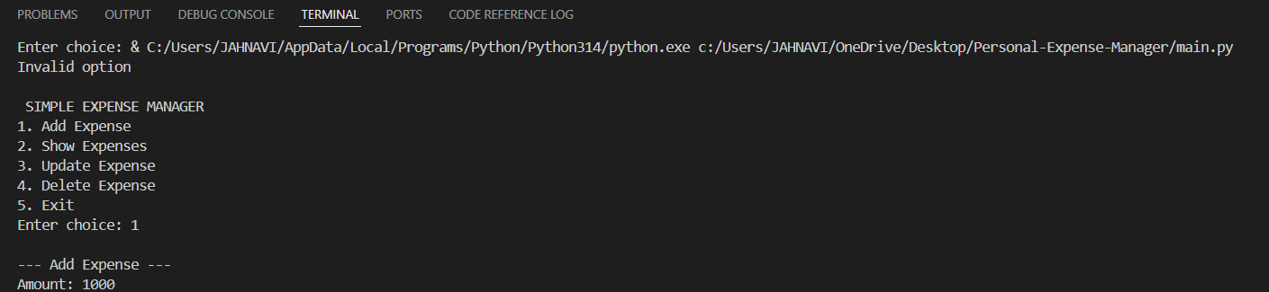

* Adding an expense

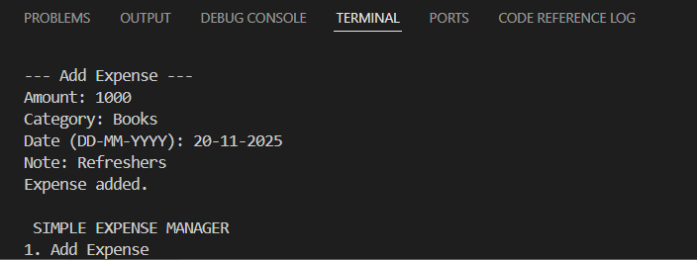

* Viewing all expenses

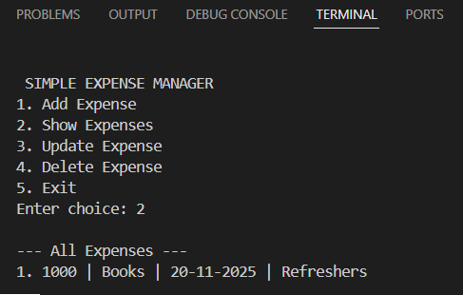

* Updating an entry

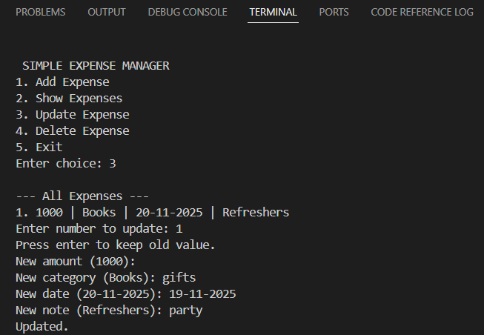

* Deleting an entry

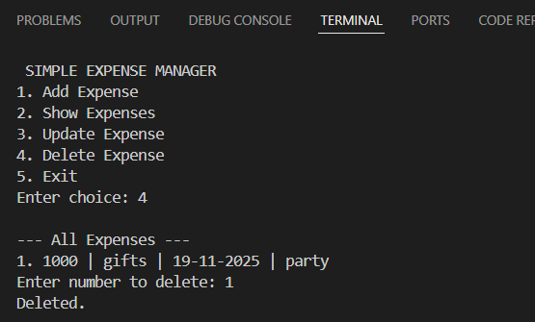

* Exit

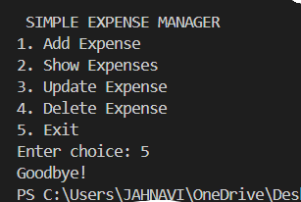

### 12. Testing Approach

I tested the project manually because it is a small console-based application. I mostly checked whether each option in the menu was working properly.

* First, I added a few expenses to see if they appear correctly.
* Then I viewed all expenses to confirm they were displaying properly.
* After that, I tried updating an expense and checking if the new details were shown.
* Lastly, I tested deleting an entry and confirmed that it was removed from the list.

These simple checks were enough to verify that all CRUD operations work as expected.

### 13. Challenges Faced

While building this project, I faced a few difficulties:

* I initially had trouble with Python imports because all files must be in the same folder.
* Understanding how to split the program into multiple modules took some time.
* Formatting the output in a clean and readable way was also a bit tricky.
* Sometimes small input mistakes caused errors, so I had to test each part carefully.

Overall, these challenges helped me learn how real projects behave.

### 14. Learnings & Key Takeaways

This project taught me a lot about Python beyond simple theory:

* I learned how to organise code into multiple files.
* I understood how classes make code cleaner.
* I got comfortable with CRUD operations.
* I learned how data can be stored in lists and passed between functions.
* I practised writing clean, understandable code.
* I also learned how to prepare documentation for a project.

These skills will definitely help me in bigger projects.

### 15. Future Enhancements

If this project is expanded later, here are some features that can be added:

* Saving expenses permanently in a JSON or text file
* Adding monthly expense summaries
* Showing charts to visualise spending
* Adding filters for categories
* Making a GUI version using Tkinter
* Turning it into a mobile app
* Exporting data to Excel

### 16. References

The following resources helped me while working on this project:

* Official Python documentation
* Class notes and course material
* W3Schools Python tutorials
* Basic GitHub documentation